1. The ‘Hello, world’.  
   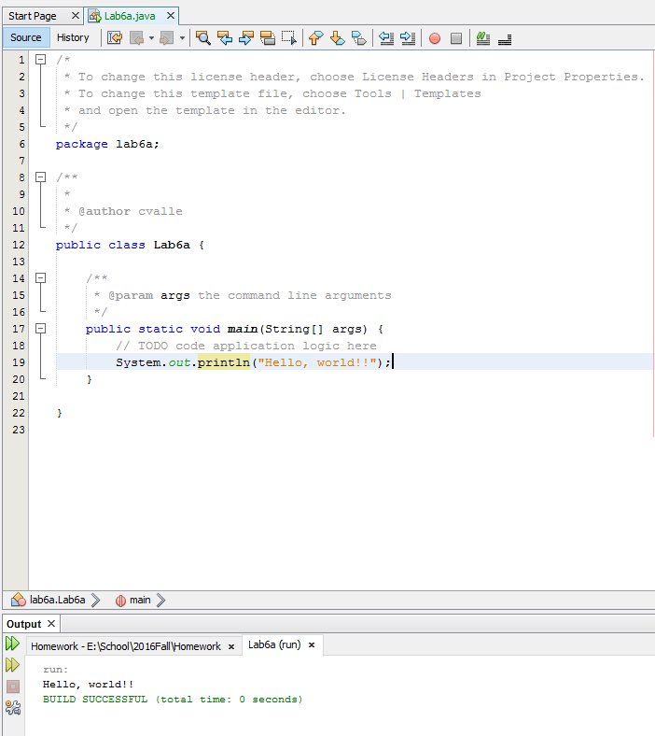
2. The ‘ArrayOps’ on a regular double array.  
   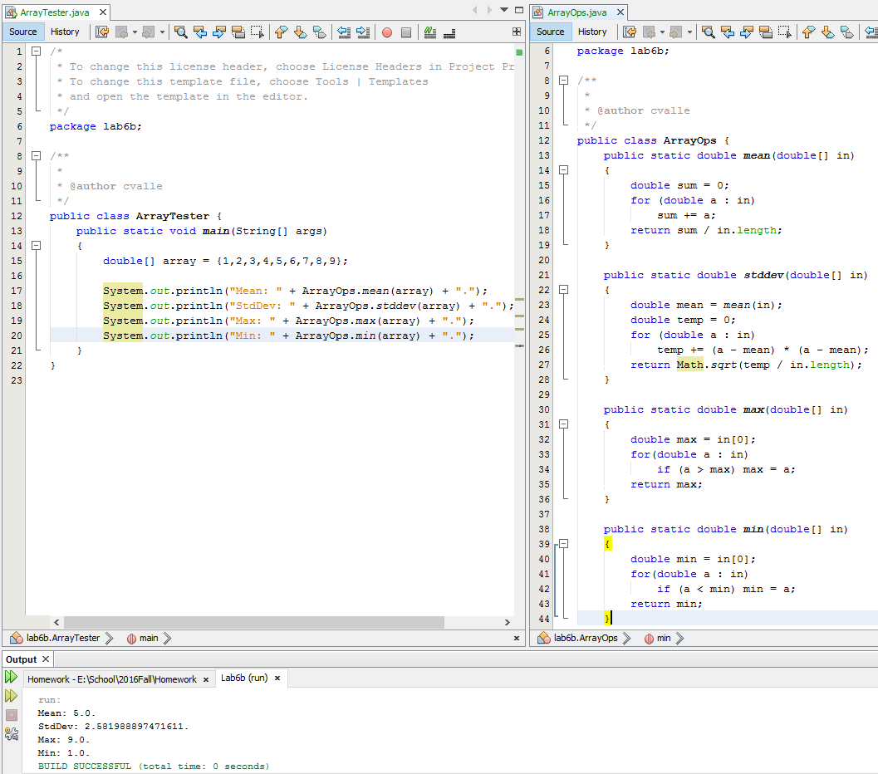
3. The ‘ArrayListOps’ on an ArrayList of doubles.  
   